Sectoral Analysis of Indian Stock Market Indices

**Student Author Name**

**Roll Number Here**

*A project report submitted for the MA (IInd Semester)*

Submitted to

Teachers Name Here

**Department of Economics**  
**Aligarh Muslim University**  
**Date of Submission**: 2025-05-16

Table of Contents

Abstract 4

1. Introduction 1

2. Data and Methodology 1

2.1 Data 1

2.2 Methodology 1

3. Results and discussion 1

3.1 Trend Analysis 1

3.2 Normality of Returns 3

3.3 Difference in Mean Returns 4

3.4 Correlation Between Sectors 4

3.5 Predicting Banking Returns 4

3.6 Volatility Comparison 4

4. Conclusion 5

5. References 5

6. Appendix: R Code 6

List of Figures

Figure 1: Trend of Bank Index 2

Figure 2: Trend of IT Index 2

Figure 3:Trend of FMCG Index 3

Figure 4: Normality of Returns 3

Figure 5:Correlation among sectoral returns 4

List of Tables

Table 1:ANOVA Results for Sectoral Returns 4

Table 2:Regression Model Predicting Bank Returns 4

Table 3:Sector-wise Volatility 4

# Abstract

Abstract of the project goes here.

# 1. Introduction

Introduction of the study goes here. For example, see the below paragraph. Sectoral indices reflect the performance of key industries within the stock market. Understanding their behavior is crucial for investors, policymakers, and analysts. This report addresses the following research questions:

* What are the trends in sector indices from 2020–2025?
* Are daily returns normally distributed?
* Do average returns differ significantly across sectors?
* Are sector returns correlated?
* Can banking returns be predicted using IT and FMCG?
* Which sector is the most volatile?
* Do returns follow a random walk?
* Is there a causal relationship among sectors?

# 2. Data and Methodology

## 2.1 Data

Write here about the data here.

## 2.2 Methodology

Write here, about the methods used for the analysis.

# 3. Results and discussion

Write here about the results which have been obtained after employing above stated methodologies and discuss about the results.

## 3.1 Trend Analysis

$Bank

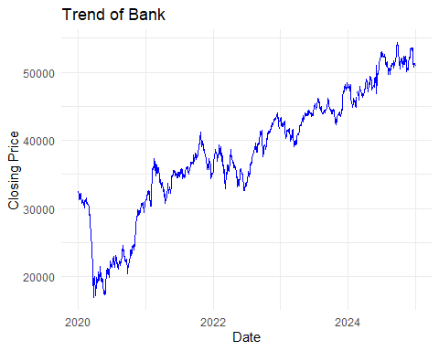

Figure : Trend of Bank Index

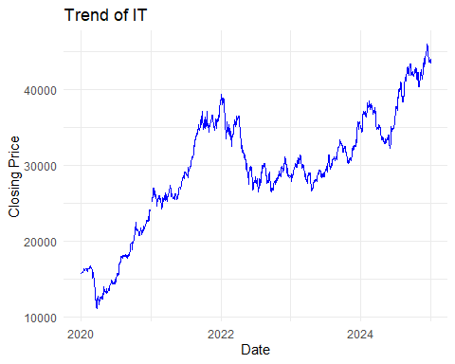

Figure : Trend of IT Index

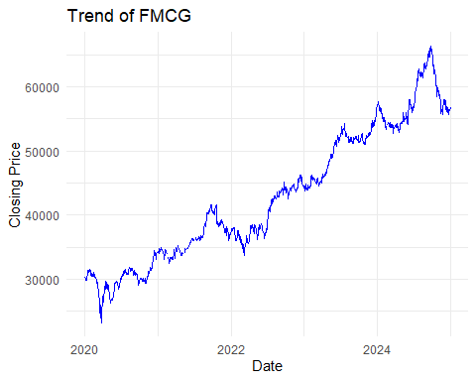

Figure :Trend of FMCG Index

## 3.2 Normality of Returns

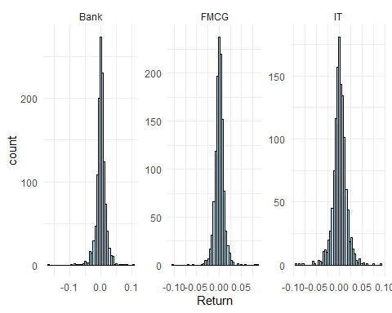

Figure : Normality of Returns

## 3.3 Difference in Mean Returns

Table :ANOVA Results for Sectoral Returns

| term | df | sumsq | meansq | statistic | p.value |
| --- | --- | --- | --- | --- | --- |
| Sector | 2 | 0.0001347 | 0.0000674 | 0.3336359 | 0.7163362 |
| Residuals | 3684 | 0.7438068 | 0.0002019 | NA | NA |

## 3.4 Correlation Between Sectors

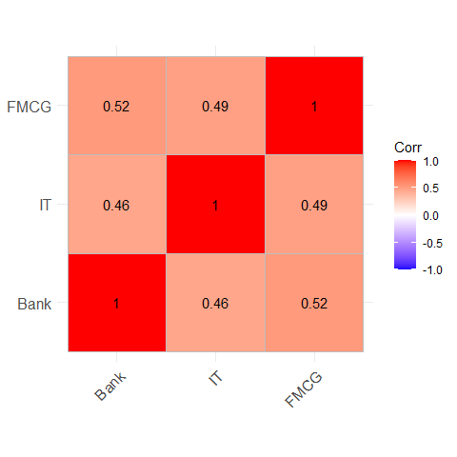

Figure :Correlation among sectoral returns

## 3.5 Predicting Banking Returns

Table :Regression Model Predicting Bank Returns

| term | estimate | std.error | statistic | p.value |
| --- | --- | --- | --- | --- |
| (Intercept) | -0.0001161 | 0.0003834 | -0.3028521 | 0.7620542 |
| IT | 0.2968386 | 0.0292104 | 10.1620744 | 0.0000000 |
| FMCG | 0.5770344 | 0.0405883 | 14.2167794 | 0.0000000 |

## 3.6 Volatility Comparison

Table :Sector-wise Volatility

| Sector | Volatility |
| --- | --- |
| Bank | 0.0162709 |
| IT | 0.0149595 |
| FMCG | 0.0107960 |

The analysis indicates that sectoral indices show distinct dynamics. Banking sector returns exhibit higher volatility, while FMCG remains relatively stable. ANOVA and regression models suggest statistically significant differences and predictive relationships across sectors. ADF results reject the random walk hypothesis, suggesting the market is not fully efficient.

# 4. Conclusion

This report highlights structural differences across sectors, predictive linkages, and implications for market efficiency. These insights support diversification strategies and inform policy planning in financial regulation.

# 5. References

* Fama, E. F. (1970). Efficient Capital Markets: A Review of Theory and Empirical Work.
* Lo, A. W., & MacKinlay, A. C. (1988). Stock Market Prices Do Not Follow Random Walks.
* Mishra, A. K., & Sethi, D. (2021). Sectoral Returns and Macroeconomic Variables: Evidence from Indian Stock Market.

# Appendix: R Code

Paste all R code here.